Unit 9 Ubuntu VirtualBox

**Corey Crooks**

**Purdue University Global**

**IT332 – Principles of Information Systems Architecture**

**Jonathan Abramson**

**September 6th, 2023**

**Screenshots**

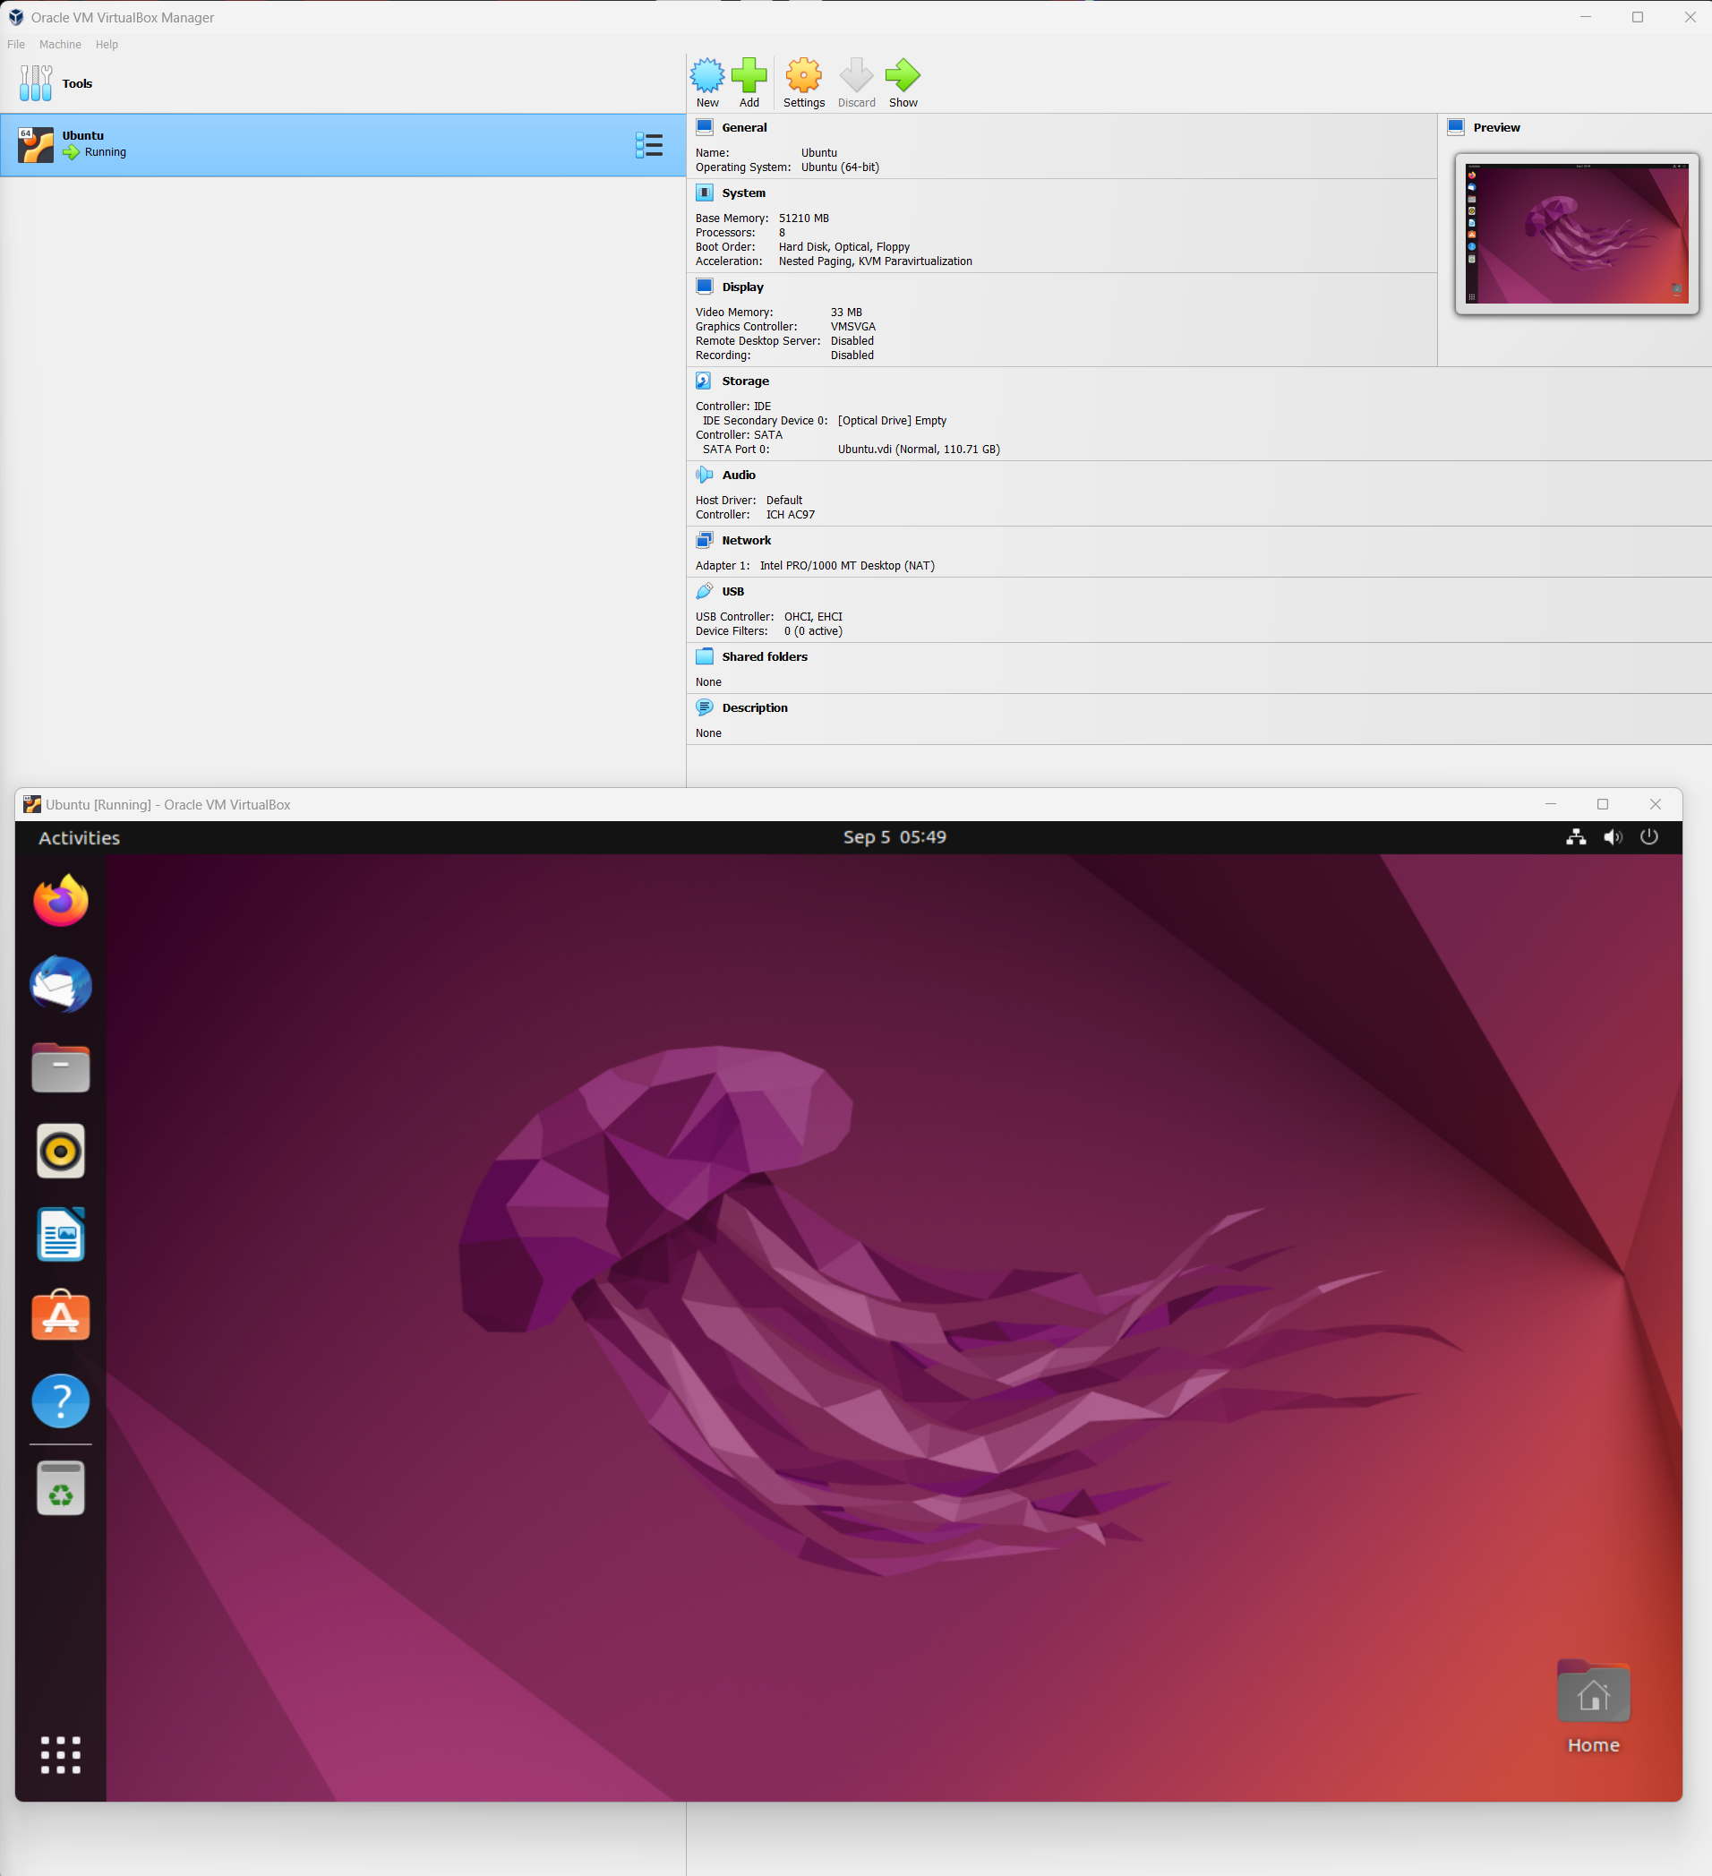

-The above screenshot lists both a successful installation of the VirtualBox, and Ubuntu Linux operating environment.

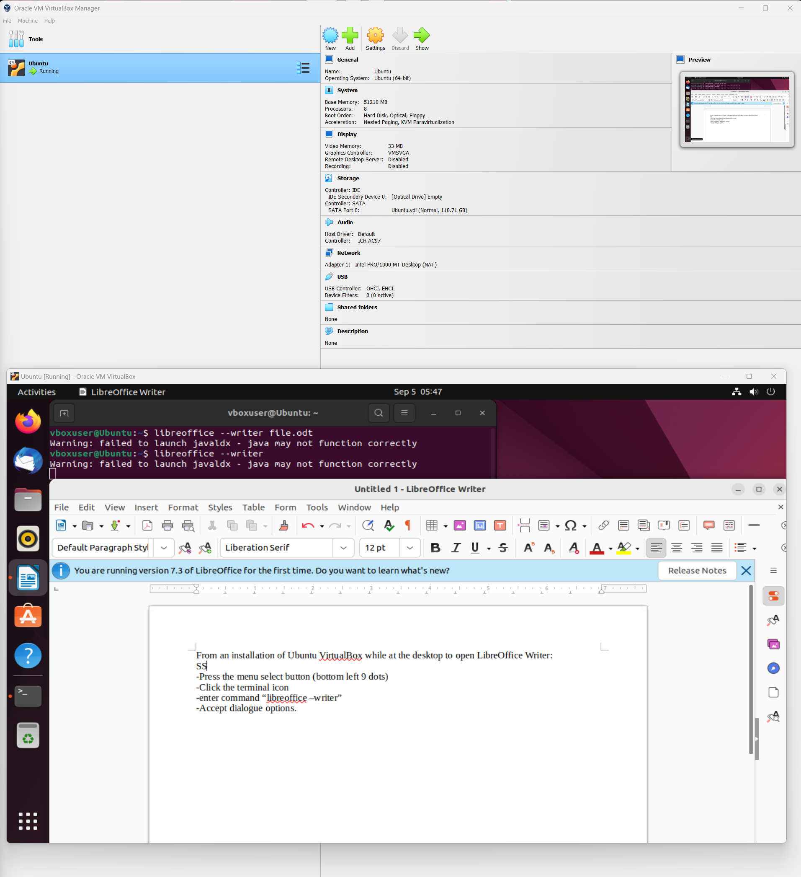

-The above screenshot illustrates a step-by-step guide on how to open the LibreOffice Writer application from a command line using LibreOffice Writer.

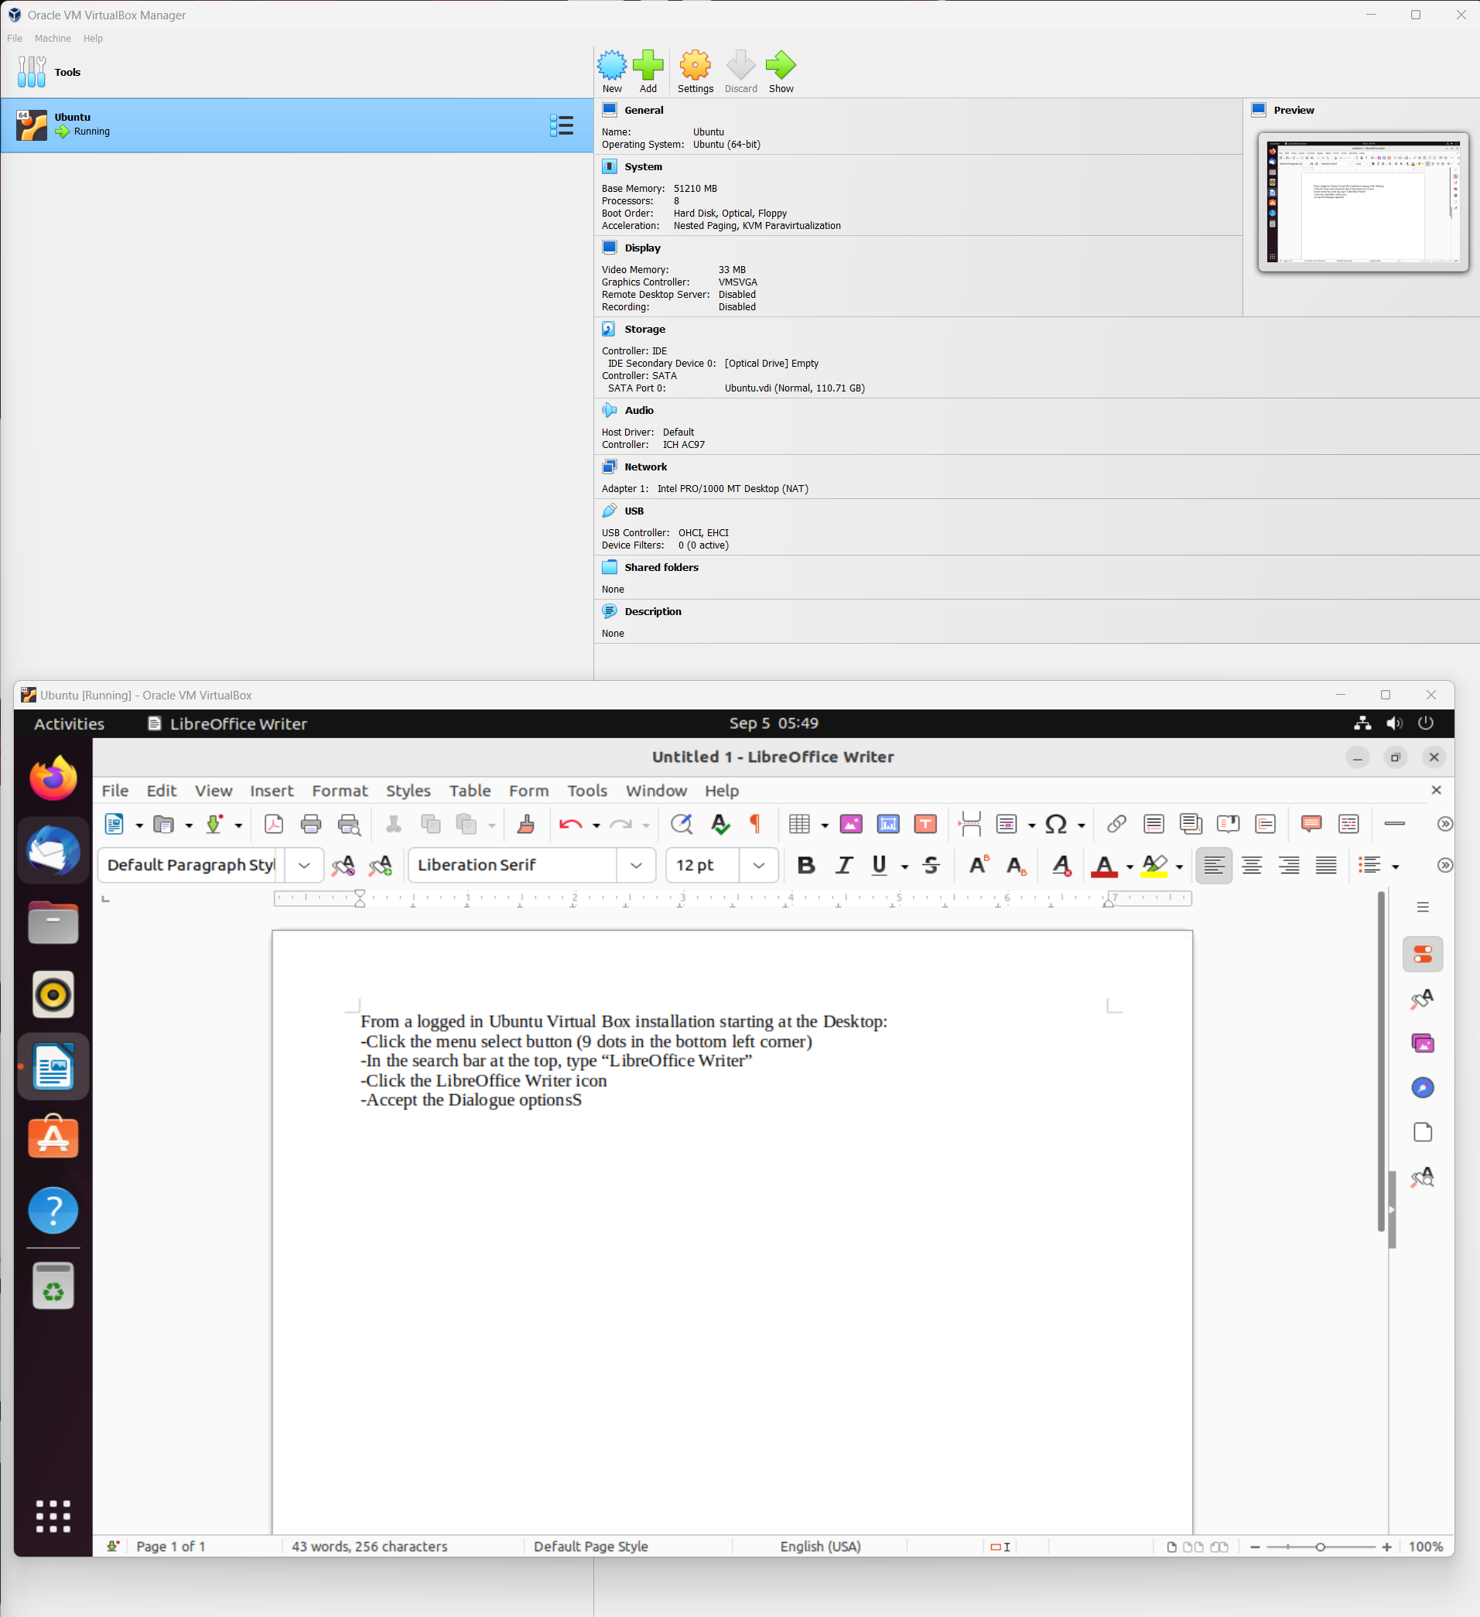

-The above screenshot illustrates a step-by-step guide on how to open the LibreOffice Writer application from the Ubuntu GUI using LibreOffice Writer.

**Complications**

I have installed a virtual machine using VirtualBox before. This was a Windows 10 installation for one of my other classes. Overall, I much prefer the Ubuntu installation. I had no difficulties with software, unlike Windows 10. Ubuntu loaded just fine unlike Windows 10. Ubuntu did not crash while installing unlike Windows 10. Ubuntu loaded into the user-select page without requiring a BIOS update to my main computer unlike Windows 10. Ubuntu let me type in my password to log in unlike Windows 10. The process of installing Ubuntu was much easier as well. In the windows installation of VirtualBox, I had to wait upwards of 15 minutes while windows displayed the “Hang tight, we’re getting things ready” message while it prepared the windows installation. Ubuntu booted right up, and then installed the extra software like LibreOffice Writer while I was logged into the Ubuntu OS. Judging by the download times, it seems like Ubuntu is much more lightweight as well compared to Windows.

The only issue I had while installing Ubuntu was due to the login screen. It seems Ubuntu comes pre-installed with a user account (I believe this is due to the VirtualBox ISO I downloaded). It took me a little bit of time to figure out how to get past this screen, since it came loaded with a set username and password that I needed to figure out. I tried booting into recovery mode and setting a new user account, but it seemed that the command line there wouldn’t let me type at all. Eventually I found out what the password was for the default account with some Google searching on my host machine. I tried “admin”, “ubuntu”, and then finally “changeme” which seems to be the correct password. At first I didn’t think it would work, but it seems for some reason, I needed to input “changeme” three times before the system accepted it as my credentials, and let me log in. From there, it was a very smooth experience. The Ubuntu UI is very easy to navigate, and the programs were quite simple to launch with an easy google search for the command line syntax. Fortunately, Ubuntu seems to work well with my computer’s architecture, so the UI and experience feels extremely responsive and smooth unlike the issues I have with my Windows 10 VM that I still have to figure out how to fix.